**Hololens Development Report**

Juwon Kim

01/10/2018 ~ 02/21/2018

1. **Development Environment**
   1. Windows 10 Enterprise
   2. Unity 3D 2017.3.0f3
   3. Visual Studio 2017 15.5
   4. HoloToolkit 2017.2.1.1 Patch Release
2. **Hololense Specs**
   1. CPU : Intel x86 1Ghz
   2. 2GB RAM, 1GB HPU RAM
   3. 64GB Storage
   4. Equipped accelerometer, gyroscope, magnetometer
3. **What is the AR?**
   1. [1]Augmented reality (AR) is a live direct or indirect view of a physical, real-world environment whose elements are "augmented" by computer-generated perceptual information, ideally across multiple sensory modalities, including visual, auditory, haptic, somatosensory, and olfactory.
   2. Difference between AR and VR
      * AR
        + Based or affected by real world
        + Use camera to cover holographic at real world
        + Use part of body as controller
      * VR
        + Based and affected by virtual world
        + There’s no camera attached at device
        + Use exclusive controller for VR
   3. AR Usage
      * Tour Application[2]
        + Hololense scanning tour route and guide tourists to right direction
        + Show up sightseeing point’s informations.
      * Science Class Application[3]
        + Student can do science experiment in AR environment.
        + It makes experiment more clean and easy.

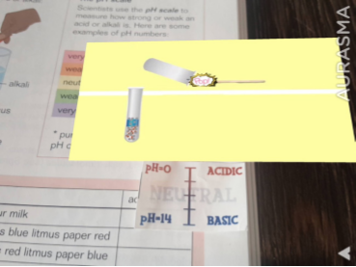

1. **How to set up hololens development environment**
   1. Install Unity 3D
   2. Download lastest Unity Holotoolkit package from here[4]
   3. Install Visual Studio 2017
   4. Install UWP(Universal Windows Platform) from here[5]
   5. Install hololens emulator from here[6]
2. **How to compile your hololens project**
   1. Add your scene at build settings.

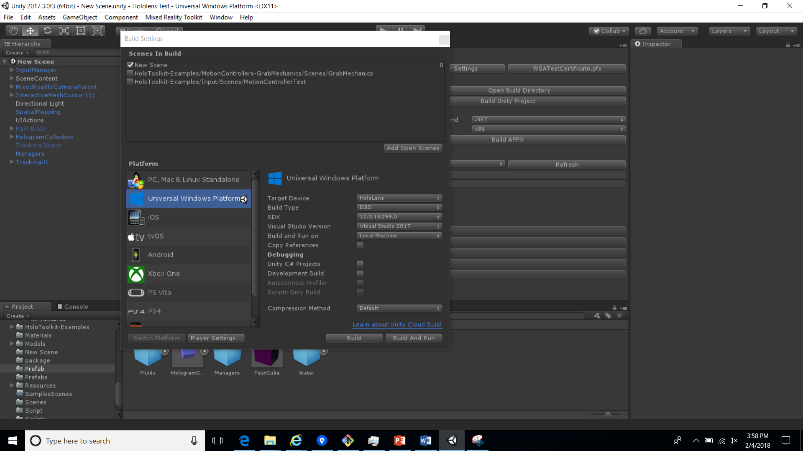

* 1. In player settings, you must check VR Supported at XR Settings.

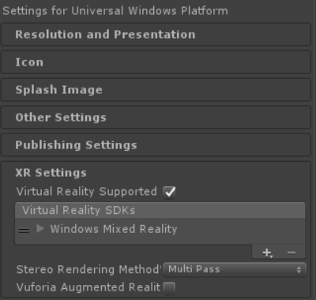

* 1. Click “Mixed Reality Tookit” menu, click “Build Window”, click “Build Unity Project and wait for building in Visual Studio Solution. After finishing building, click “Open Project Solution”

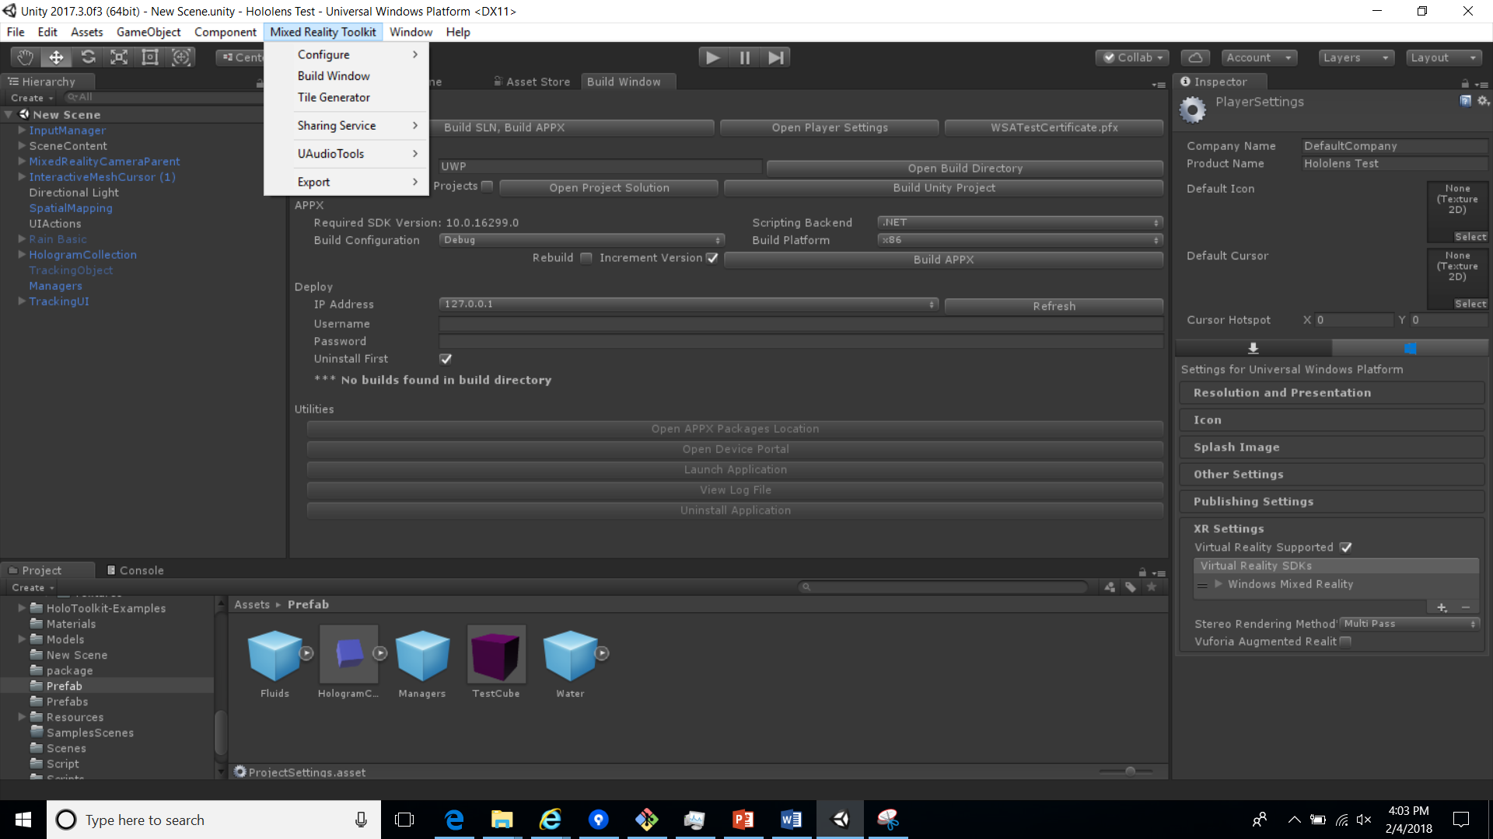

* 1. Right click your solution and click properties. And check “Uninstall and then re-install ~”, “Deploy optional packages” options.

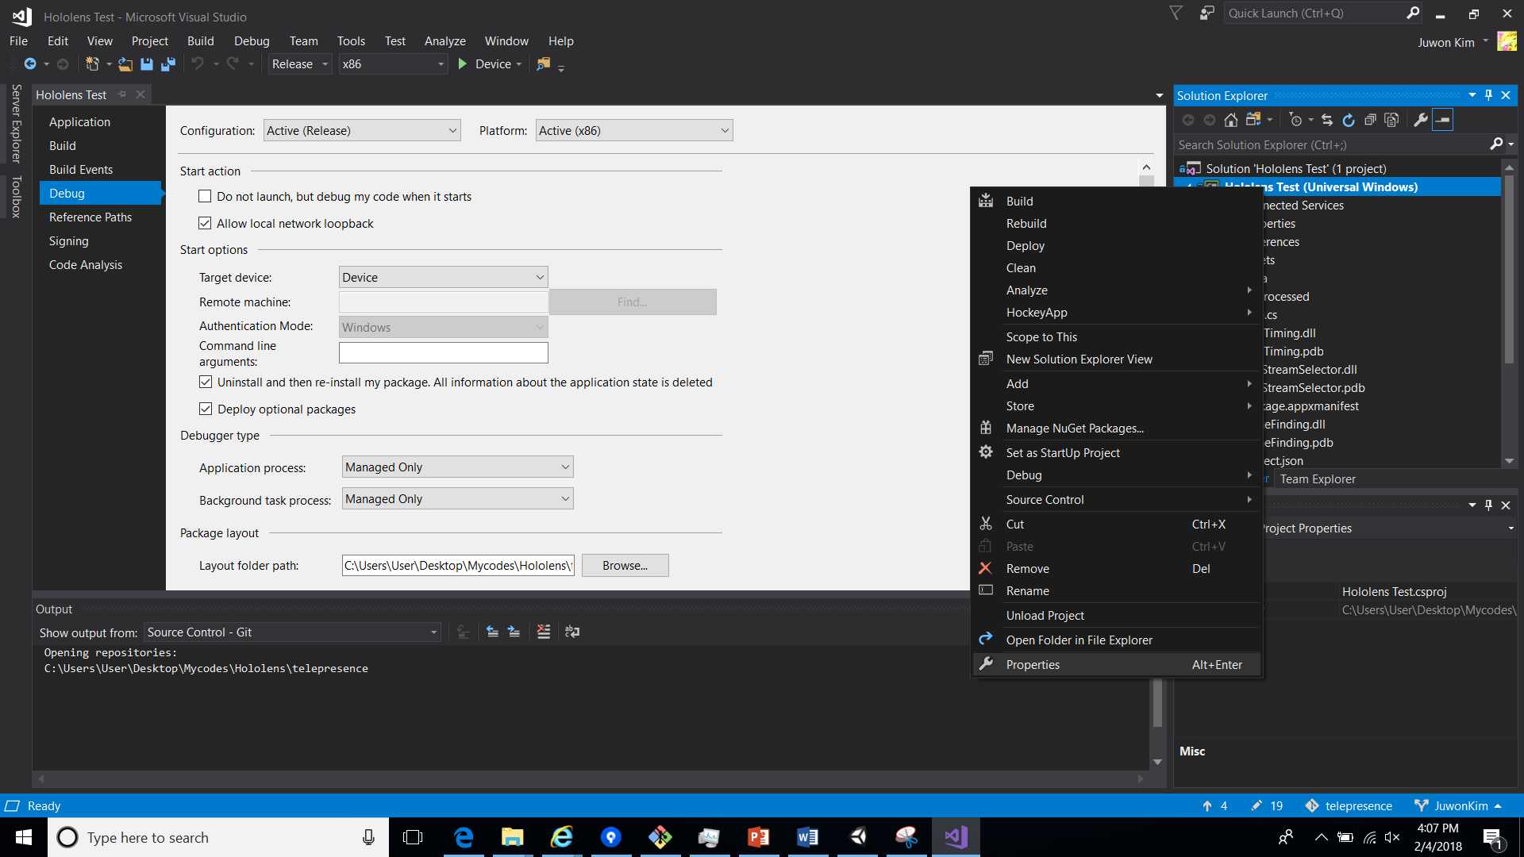

* 1. Set your building setting like this and click build button.



1. **What you have to know before develop hololense apps**
   1. Spatial Mapping range : 0 yards ~ 8 yards
      * 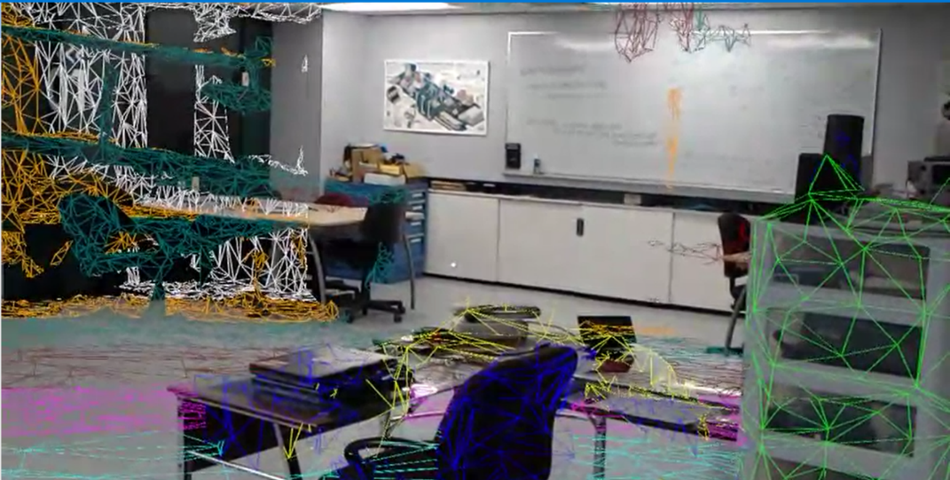

Each color means 1 meter(1.09 yards)

* + - Spatial Mapping will not be fully functional at large space.
  1. Virtual Object view enable range : 1 foot 7 in ~
     + In Unity 3D, object must be far 0.5 from camera
  2. You must use “Occlusion Culling” feature for optimization.
     + “Occlusion Culling” feature helps optimize application. Check this docs[7] to implement this feature.
  3. You can’t use “UI canvas” for Hololense app. Because All of interactive UI panel or buttons must be in 3D dimension environment.

1. **My Development Log of Hololens**
   1. Hololens Camera

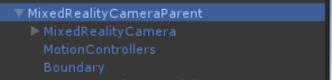

* + - You can find “MixedRealityCameraParent” in Holotoolkit pacakage. This prefab gives area which you can make virtual object in reality world.
  1. Cursor

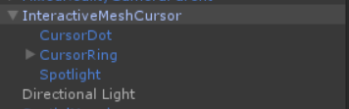

* + - There some cursor prefab for hololens in HololensTookit. This cursor prefab can use as mouse function. And this prefab response from user’s gesture in hololens.
  1. UI
     + You must use 3D object when making UI for hololens. Typical Unity applications are using UI canvas as UI system, but hololens is little bit different.
     + First you have to consider that hololense UI environment is 3D. For example if you want to attach label in UI, you have to attach two label that one is front label and another one is rear label.
     + 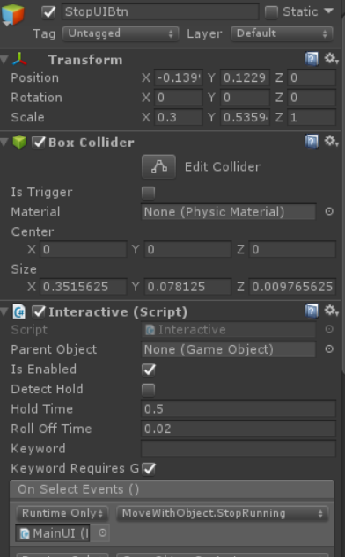
     + When you’re going to make button for hololens, first you make 3D object and attach “Interactive” script which contained HololensToolkit. OnClick() method in UI Button is same as OnSelectEvent() method in Interactive script.
     + If you want to move or adjust UI scale, use “MoveWithObject” script or “ScaleByDistance” script.
  2. Spatial Mapping

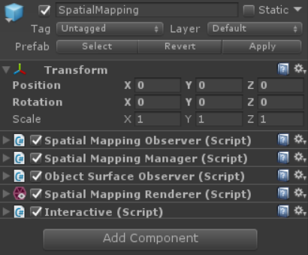

* + - This prefab helps mapping real world. If you using Unity3D over 2017.2.0 version, you have to use “SpatialMappingRenderer”. This script is provided by Unity3D XR function. You can see docs at here[8]
    - You can use “Interactive” script for event which user clicks real world.
  1. Editing objects
     + Referencing this site[9], I implemented object resize, rotate, and dragging. But you have to make UI environment your own for controlling object.
  2. Tracking Hands
     + Referencing this site[10], I implemented object that tracking hands.
     + I use triangle function to tracking UI follow user naturally.
  3. Call object and place at real world
     + The object need collider component in prefab.
     + Use “Interactive” script to make interactive object
     + At “SpatialMappingRenderer” component, you have to attach “Spatial Mapping Collider” component also.
     + If you want to attach function that resize, rotate, or drag, reference this site[11]
  4. Measure Function
     + Use “HoloToolKit-Example/GazeRuler”
     + Extract “MeasurePrefab” and attach to other scene
     + Do not set this prefab as inactive during runtime
  5. Make Virtual Hole
     + Same way as placing virtual object
     + Spatial Mapping Renderer’s material must be same as Virtual Hole material.
     + Virtual hole prefab structure
     + 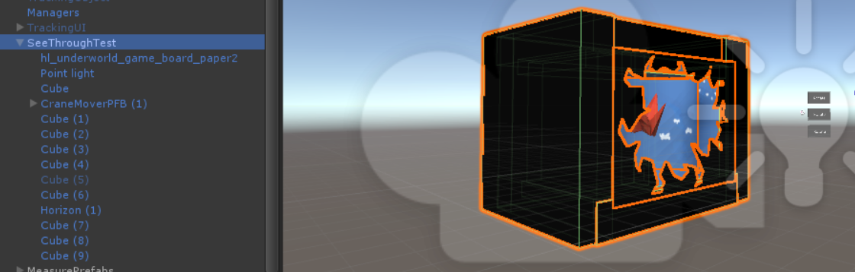
  6. How to make fixed UI which joint with Hololense Camera
     + Make UI group be child component of “MixedRealityCamera” prefab.
     + 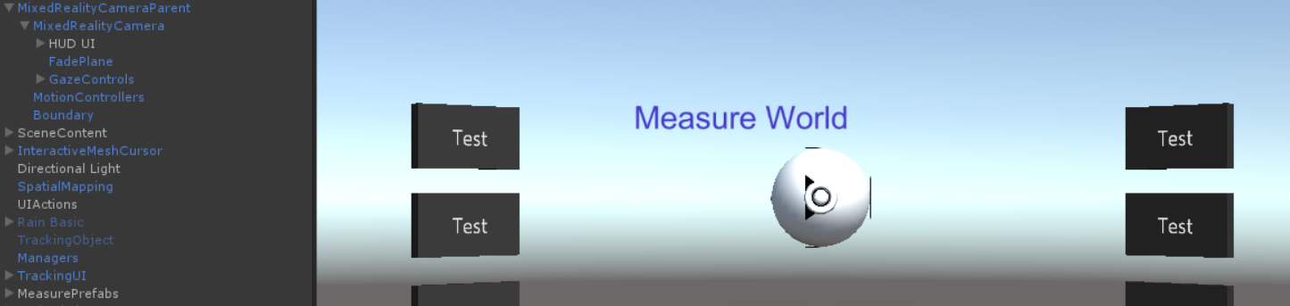
  7. How to make object keep following user
     + Use this fomula in object’s component.
     + Z : Object’s z coordinate
     + X : Object’s x coordinate
     + D : Distance from camera
     + Cz : Camera’s z coordinate
     + Cx : Camera’s x coordinate
     + Ry : Camera’s y eular angle

1. <https://en.wikipedia.org/wiki/Augmented_reality>
2. Article) CityGuideTour Toruń - tourist application using augmented reality
3. Article) Student Opinions on Mobile Augmented Reality Application and Developed Content in Science Class / Damla Karagozlu , Fezile Ozdamli ,Near East University,Nicosia, Cyprus
4. <https://github.com/Microsoft/MixedRealityToolkit-Unity/releases>
5. <https://developer.microsoft.com/en-US/windows/downloads/windows-10-sdk>
6. <https://go.microsoft.com/fwlink/?linkid=852626>
7. <https://docs.unity3d.com/Manual/OcclusionCulling.html>
8. <https://docs.unity3d.com/ScriptReference/XR.WSA.SpatialMappingRenderer.html>
9. <https://www.billmccrary.com/holotoolkit-simple-dragresizerotate/>
10. <https://github.com/ritchielozada/HoloLensHandTracking>
11. <https://www.billmccrary.com/holotoolkit-simple-dragresizerotate/>